30.43: a)
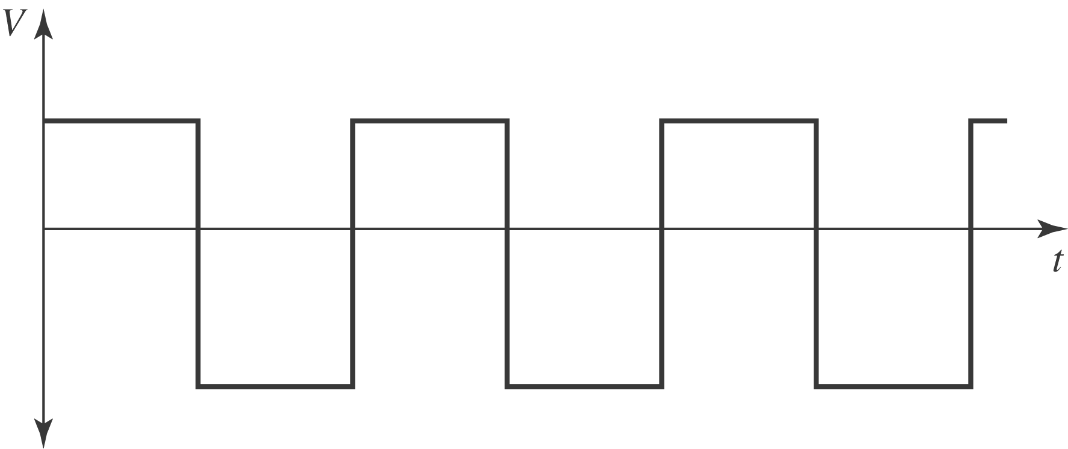
b) Since the voltage is determined by the derivative of the current, the V versus t graph is indeed proportional to the derivative of the current graph.

